Faith & Life Objectives  Build a Firm Foundation in the Faith  We are committed to building our faith on the rock,  not on shifting sands. At the end of this leg of the journey:  - I will understand the basics of Christian doctrine, such as the character of God, justification, sanctification, the church, the Bible, the person of Christ, and the work of the Holy Spirit. (Head)  - I will learn to trust God for my righteousness and security rather than my own strength. (Heart)  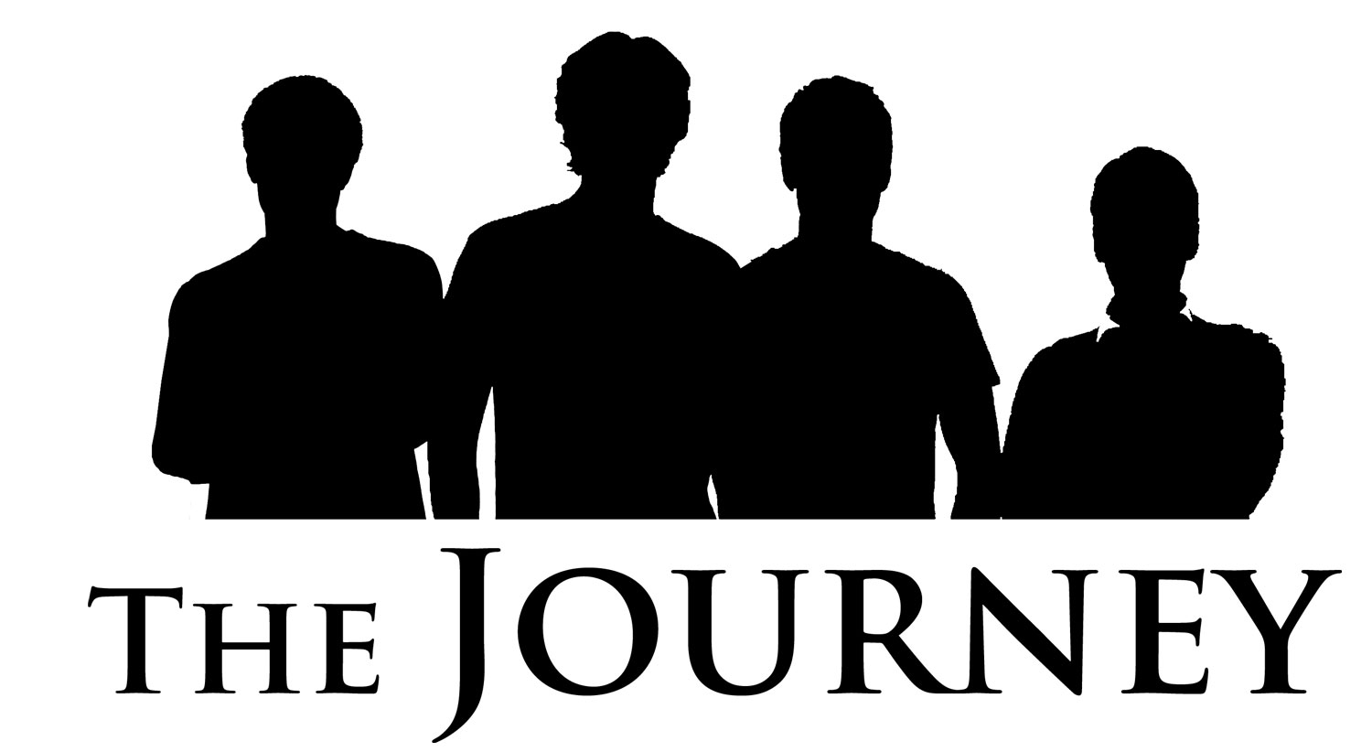  - I will have developed the habits of a learner and will continue to grow in my knowledge and love for God. (Hands) www.maninthemirror.org | Faith & Life Objectives  Build a Firm Foundation in the Faith  We are committed to building our faith on the rock,  not on shifting sands. At the end of this leg of the journey:  - I will understand the basics of Christian doctrine, such as the character of God, justification, sanctification, the church, the Bible, the person of Christ, and the work of the Holy Spirit. (Head)  - I will learn to trust God for my righteousness and security rather than my own strength. (Heart)  - I will have developed the habits of a learner and will continue to grow in my knowledge and love for God. (Hands) www.maninthemirror.org
Faith & Life Objectives  Build a Firm Foundation in the Faith  We are committed to building our faith on the rock,  not on shifting sands. At the end of this leg of the journey:  - I will understand the basics of Christian doctrine, such as the character of God, justification, sanctification, the church, the Bible, the person of Christ, and the work of the Holy Spirit. (Head)  - I will learn to trust God for my righteousness and security rather than my own strength. (Heart)  - I will have developed the habits of a learner and will continue to grow in my knowledge and love for God. (Hands) www.maninthemirror.org | Faith & Life Objectives  Build a Firm Foundation in the Faith  We are committed to building our faith on the rock,  not on shifting sands. At the end of this leg of the journey:  - I will understand the basics of Christian doctrine, such as the character of God, justification, sanctification, the church, the Bible, the person of Christ, and the work of the Holy Spirit. (Head)  - I will learn to trust God for my righteousness and security rather than my own strength. (Heart)  - I will have developed the habits of a learner and will continue to grow in my knowledge and love for God. (Hands) www.maninthemirror.org
Faith & Life Objectives  Build a Firm Foundation in the Faith  We are committed to building our faith on the rock,  not on shifting sands. At the end of this leg of the journey:  - I will understand the basics of Christian doctrine, such as the character of God, justification, sanctification, the church, the Bible, the person of Christ, and the work of the Holy Spirit. (Head)  - I will learn to trust God for my righteousness and security rather than my own strength. (Heart)  - I will have developed the habits of a learner and will continue to grow in my knowledge and love for God. (Hands) www.maninthemirror.org | Faith & Life Objectives  Build a Firm Foundation in the Faith  We are committed to building our faith on the rock,  not on shifting sands. At the end of this leg of the journey:  - I will understand the basics of Christian doctrine, such as the character of God, justification, sanctification, the church, the Bible, the person of Christ, and the work of the Holy Spirit. (Head)  - I will learn to trust God for my righteousness and security rather than my own strength. (Heart)  - I will have developed the habits of a learner and will continue to grow in my knowledge and love for God. (Hands) www.maninthemirror.org
Faith & Life Objectives  Build a Firm Foundation in the Faith  We are committed to building our faith on the rock,  not on shifting sands. At the end of this leg of the journey:  - I will understand the basics of Christian doctrine, such as the character of God, justification, sanctification, the church, the Bible, the person of Christ, and the work of the Holy Spirit. (Head)  - I will learn to trust God for my righteousness and security rather than my own strength. (Heart)  - I will have developed the habits of a learner and will continue to grow in my knowledge and love for God. (Hands) www.maninthemirror.org | Faith & Life Objectives  Build a Firm Foundation in the Faith  We are committed to building our faith on the rock,  not on shifting sands. At the end of this leg of the journey:  - I will understand the basics of Christian doctrine, such as the character of God, justification, sanctification, the church, the Bible, the person of Christ, and the work of the Holy Spirit. (Head)  - I will learn to trust God for my righteousness and security rather than my own strength. (Heart)  - I will have developed the habits of a learner and will continue to grow in my knowledge and love for God. (Hands) www.maninthemirror.org
Faith & Life Objectives  Build a Firm Foundation in the Faith  We are committed to building our faith on the rock,  not on shifting sands. At the end of this leg of the journey:  - I will understand the basics of Christian doctrine, such as the character of God, justification, sanctification, the church, the Bible, the person of Christ, and the work of the Holy Spirit. (Head)  - I will learn to trust God for my righteousness and security rather than my own strength. (Heart)  - I will have developed the habits of a learner and will continue to grow in my knowledge and love for God. (Hands) www.maninthemirror.org | Faith & Life Objectives  Build a Firm Foundation in the Faith  We are committed to building our faith on the rock,  not on shifting sands. At the end of this leg of the journey:  - I will understand the basics of Christian doctrine, such as the character of God, justification, sanctification, the church, the Bible, the person of Christ, and the work of the Holy Spirit. (Head)  - I will learn to trust God for my righteousness and security rather than my own strength. (Heart)  - I will have developed the habits of a learner and will continue to grow in my knowledge and love for God. (Hands) www.maninthemirror.org

