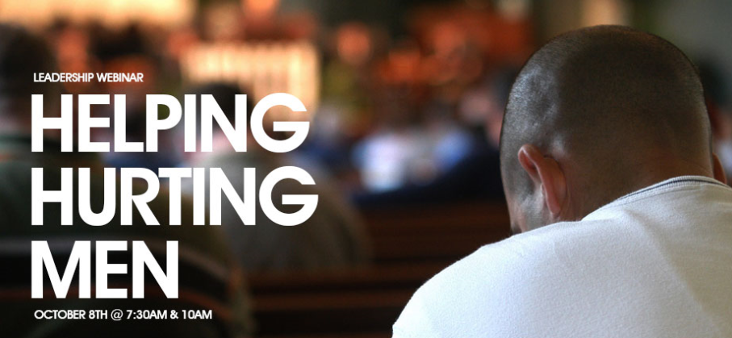

**Jeff Kisiah /Coach “K” -National Field Director**/Man in the Mirror

When the “ships dock” in the “harbor” of the average church on any given Sunday, we rarely get below the “water line” to know the current saga of a man’s world.

Regardless of their spiritual maturity, all men go through difficulties at various times in their lives. At any given point, a large majority in your church may be going through a tremendous challenge.

Patrick Morley suggests that men may suffer for one or more of three reasons:

1. For doing *wrong*
2. For doing *right*
3. For *no apparent reason*

Paul reminded the Church at Galatia to be fully aware of the Season of Suffering:

***“Broken Mirrors”*** – ***Galatians 6:2***

***Ministry...*NMLB/Chapters 1-4**

*“****Bear*** *one another’s burdens, and so fulfill the law of Christ.”* (ESV)

*“You obey the law of Christ when you offer each other a* ***helping hand****.”* (CEV)

*“By* ***helping each other*** *with your troubles, you truly obey the laws of Christ.”* (NCV)

*“****Carry*** *each other’s burdens, and in this way you will fulfill the law of Christ.”* (NIV)

*“Share each other’s* ***troubles*** *&* ***problems****, & so obey our Lord’s commands.”* (TLB)

*“Stoop down &* ***reach out*** *to those who are oppressed…”* (MSG)

***MEN***

***Ministry...*NMLB/Chapters 1-4**

Every man in your church (and community) fits into one or more of the following five categories…

**5 Types: Life Focus:**

* *Natural Man* = _*__________________________*
* *Cultural Christian*= *___________________________*
* *Biblical Disciple* = ______________*_____________*

* *Servant Leader* = ______________*_____________*
* ***Hurting Man*** = ______________*_____________*

The Hurting Man is not part of a separate category of men. He comes from one of the first four categories.

***HURTING Men***

***Ministry...*NMLB/Chapters 1-4**

H ealth Matters =

U nexpected Crisis =

R elationship Problems =

T emperament Risks =

I solation Issues =

N­ atural Disasters =

G od’s Sovereignty =

***HELPING Hurting Men***

***Ministry...*NMLB/Chapters 1-4**

*“Stoop down &* ***reach out*** *to those who are oppressed…”* (MSG)

R = __________________________________________

*\*Isaiah 41:10*

E = __________________________________________

*\*Hebrews 10:24*

A = __________________________________________

*\*John 16:33*

C = __________________________________________

*\*Ecclesiastes 4:12*

H = __________________________________________

*\*Romans 15:13*

*Additional Notes: