
Men—
We’re excited to be on the Journey together! As you know, we’re in the challenge, Master the Essentials of Biblical Manhood.

I can’t wait to see what God’s going to do in each of us over these coming weeks. Our prayer is that we all grow in our knowledge, belief and behavior—our Head, Heart, and Hands.
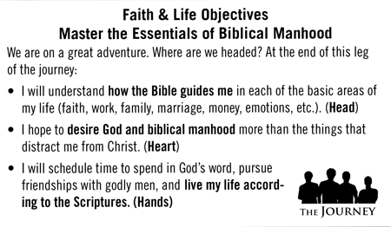
Some of us are studying the book The Man in the Mirror right now, learning about everything from integrity to time management to anger. If you can’t be a part of the study—or if you want an additional resource—we want you to join us by watching this free video series.

Each week I’ll be sending out a link to a video Bible study called the Man in the Mirror Remix, which corresponds with the book study. This first week is called “The Rat Race.”

To watch this 40-minute study, click on the link below. Note: you will be asked to create a user id and password for this website. This membership is FREE and enables you to access all the free videos.

http://maninthemirror.org/index.php?option=com_hwdvideoshare&task=viewvideo&Itemid=297&video_id=2480

Here are some questions for you to consider afterward:

- Which rat trap tempts you the most, and why?
- In the Message, a paraphrased version of the Bible, Matthew 23:12b reads, “If you are content to simply be yourself, your life will count for plenty.” Is contentment hard or easy for you, and why? Do you worry that your life will count and, if so, how does this verse speak to you? Would memorizing it be helpful? If so, consider underlining it and put it where you will see it several times a day.
- Of the ways we can get out of the rat race mentioned today, which one resonates with you?

Is there some way I can pray for you at this time? We’re all in this together and I’m looking forward to finishing this challenge strong, one stop along the way in our Journey to Biblical Manhood!
Sincerely,
Men’s Leadership Team

