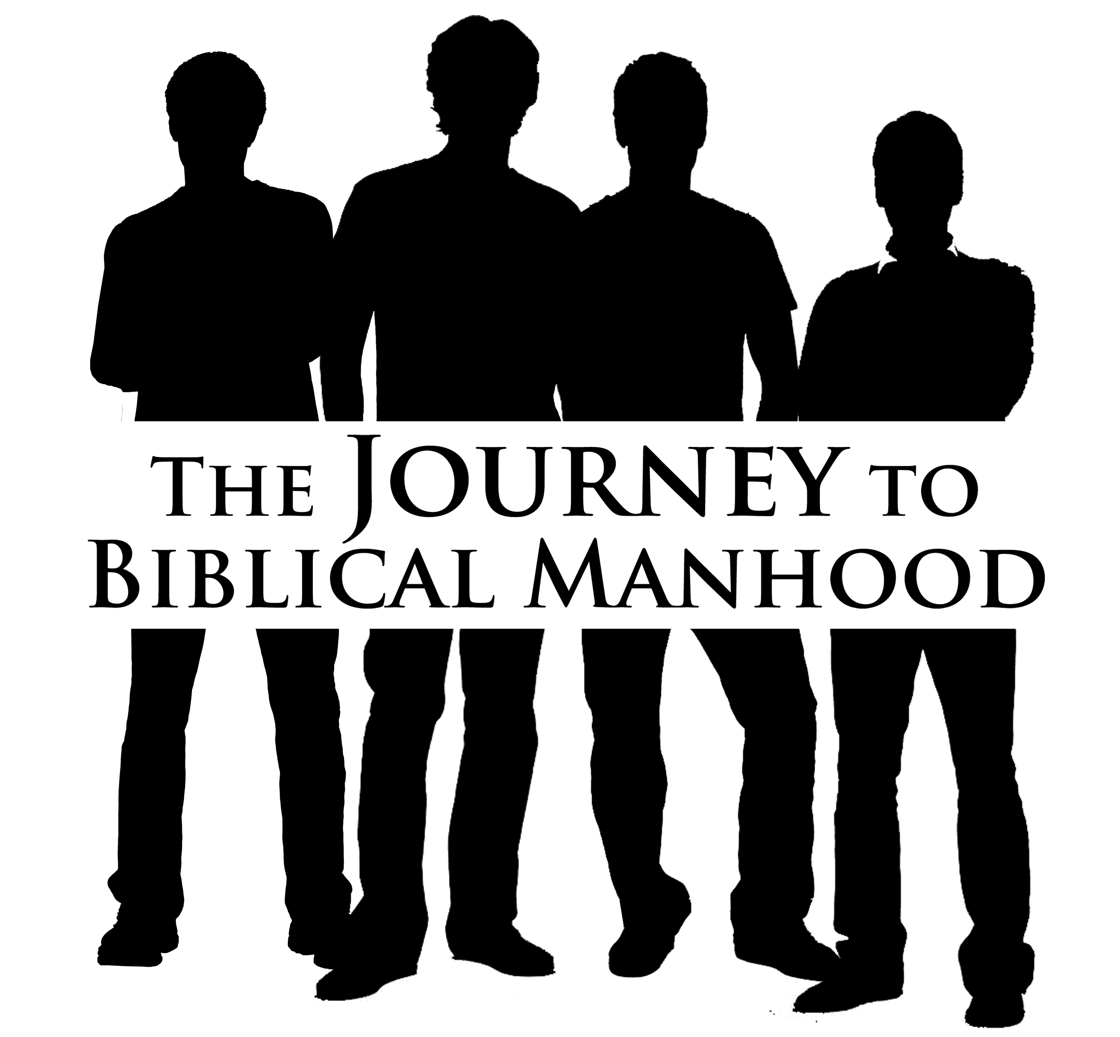
The Essentials of Biblical Manhood Survey

For the past few months, we have been challenging the men of our church to master the essentials of biblical manhood. We would like to take a snapshot of where our men are today in their understanding of Scripture and its relevance to our lives. Please take a few moments to answer the questions below.

Name (if desired): ____________________________ Date: _______________

1. I have a good understanding of what the Scriptures have to say about the following areas of my life:
Not at all Absolutely

Work 1 2 3 4 5 6
Money 1 2 3 4 5 6
Marriage (if married) 1 2 3 4 5 6
Fathering (if a father) 1 2 3 4 5 6
Emotions 1 2 3 4 5 6
Service 1 2 3 4 5 6

2. At this point in my life, I feel like I am ___________ to live as a godly man.

Not equipped at all 1 2 3 4 5 6 Totally equipped

3. Thinking about the last few months, rate your desire to pursue Christ and avoid the distractions of the world.

Totally distracted 1 2 3 4 5 6 Totally focused

4. How disciplined have you been in the last few months in pursuing opportunities to grow in faith as a godly man, such as regular Bible study?

Not at all 1 2 3 4 5 6 Very disciplined

5. We’ve offered several activities to challenge men to learn what Scriptures have to say about the way we live. Other ministries of the church were also encouraging the essentials of biblical manhood to men in various ways. How engaged have you been in intentional discipleship over the past few months?

Not engaged at all 1 2 3 4 5 6 Very engaged

Challenge 1 – Manhood: Master the Essentials of Biblical Manhood – Post-Assessment

The Essentials of Biblical Manhood Survey

For the past few months, we have been challenging the men of our church to master the essentials of biblical manhood. We would like to take a snapshot of where our men are today in their understanding of Scripture and its relevance to our lives. Please take a few moments to answer the questions below.

Name (if desired): ____________________________ Date: _______________

1. I have a good understanding of what the Scriptures have to say about the following areas of my life:
Not at all Absolutely

Work 1 2 3 4 5 6
Money 1 2 3 4 5 6
Marriage (if married) 1 2 3 4 5 6
Fathering (if a father) 1 2 3 4 5 6
Emotions 1 2 3 4 5 6
Service 1 2 3 4 5 6

2. At this point in my life, I feel like I am ___________ to live as a godly man.

Not equipped at all 1 2 3 4 5 6 Totally equipped

3. Thinking about the last few months, rate your desire to pursue Christ and avoid the distractions of the world.

Totally distracted 1 2 3 4 5 6 Totally focused

4. How disciplined have you been in the last few months in pursuing opportunities to grow in faith as a godly man, such as regular Bible study?

Not at all 1 2 3 4 5 6 Very disciplined

5. We’ve offered several activities to challenge men to learn what Scriptures have to say about the way we live. Other ministries of the church were also encouraging the essentials of biblical manhood to men in various ways. How engaged have you been in intentional discipleship over the past few months?

Not engaged at all 1 2 3 4 5 6 Very engaged

Challenge 1 – Manhood: Master the Essentials of Biblical Manhood – Post-Assessment

