The United Methodist Church


Men’s Ministry Specialist

Program Overview
Class of 2006
A Few Called Men…
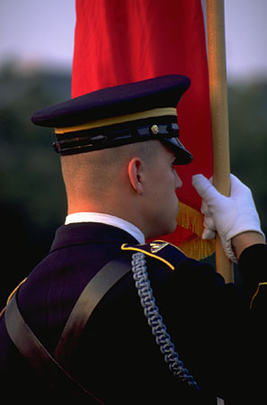
We are looking for a few called men to serve on the front lines of men’s ministry in the United Methodist Church. Men’s Ministry Specialists will be equipped to serve the local church and offer leadership to the district and conference level.

Training Tools…
Over the course of the upcoming year, the candidate for men’s ministry specialist will…
1) Attend Kickoff Weekend
2) Participate in Disciple Bible Study
3) Complete six training modules designed to equip and prepare men for men’s ministry.

Men’s Ministry School…
The Kickoff Building a Sustainable Men’s Ministry (Orlando)
The On-going Journey Walking With God (Disciple Bible Study)
Module #1 UM History & Polity
Module #2 Personal and Corporate Vision
Module #3 The Masculine Spirit
Module #4 Dynamic Leadership Development
Module #5 Ministry Tools & Organizational Change
Module #6 Personal Ministry Planning

Partners in Ministry…
The General Commission on United Methodist Men
Man in the Mirror
A Seminary Partner

Men’s Ministry Specialist Attribute Inventory

A man called to ministry to and through men.

A heart committed to the pursuit of God,
the lives of men and change from the inside out.

A mind willing to learn and possess the gifts, skill
and knowledge to effectively coach Men’s Ministry Teams across the nation.

A humble soul called by God
and committed to the long term goal
of changing the church - one man at a time.

Men’s Ministry Specialist Covenant
- I commit to walk closely with God and strive to resemble Christ in my thoughts, deeds and motives.
- I commit to grow closer to God through prayer, scripture, worship and service.
- I commit to be a man with a heart for ministry to and through men

As a men’s ministry specialist, I will help men in their spiritual journeys,
life struggles and operate as a vital part of a small platoon men.
In this platoon, I will forge powerful Christian bonds of friendship
and earn respect from the core leadership of my church and community.

I commit to helping my church become more effective in reaching men
and I will serve out of a deep love of God and all humanity
On a larger scale, I will help other churches that desire to build men’s ministry
and serve as an advisor and coach to other platoons of men.

The Kickoff Weekend
Building A Sustainable Men’s Ministry
Man in the Mirror Headquarters
Orlando, Florida
October 27-29th
Alternate Weekend: January 2006
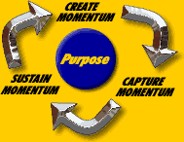
Building Sustainable Men’s Ministry
This weekend training seminar, hosted by GCUMM, Pat Morley and the Man in the Mirror staff, is designed to provide men with the underlying principles and philosophy of men’s ministry.

We will identify the foundational building blocks that are necessary to build and sustain men’s ministry and you will leave fired-up and ready to become a Men’s Ministry Specialist.

The On-Going Journey
Disciple Bible Study - Walking With God
January – December 2006


The DISCIPLE Bible Study program is designed to develop strong Christian local churches through the in-depth study of Scripture. Through DISCIPLE, the men’s ministry specialist and his platoon of men will be strengthened in their faith and guided into service and men’s ministry.

Module #1 – United Methodist History & Polity
April – June 2006
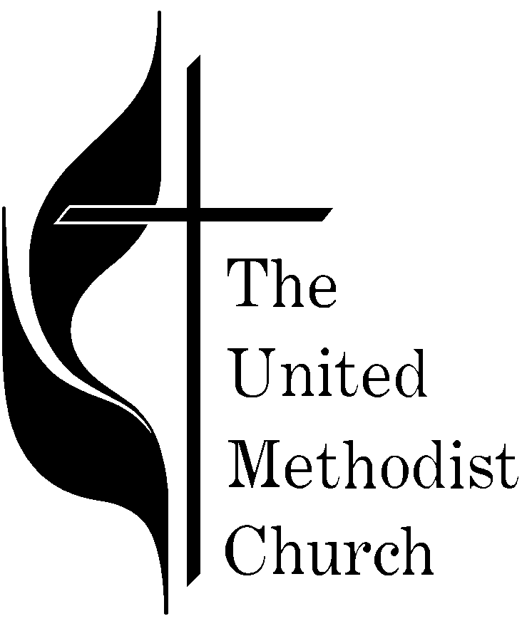

UM History, Polity & Local Church Dynamics
This course will look at the history, foundation, structure, and polity of the United Methodist Church. Beginning with John Wesley, you will understand the dynamics of our connectional system and its potential to impact the world with the saving message of Jesus Christ. It will also arm men with the capability to enter any church dynamic, or structure and feel confident and comfortable.

Module #2 – Personal and Corporate Vision Casting
April – June 2006

Personal & Corporate Vision Casting
This powerful course complements Walking With God and the Disciple Bible Study. How does a man prioritize and set God-given goals for himself and his ministry?

Define vision
Strategize vision
Implement Vision
Navigate Organizational Change
Sustain Vision

Module #3 – The Masculine Spirit
Summer Semester July – September 2006

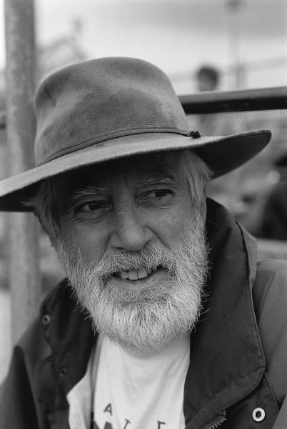
The Masculine Spirit
In churches today there is often an imbalance between feminine and masculine. The church must become more effective at establishing this balance.

This course is designed to…
- To help men understand the mixed messages that church sends
- To help men make the church more effective with men to and through men
- To honor and bless women and children.
- To ascribe worth to the men of the church
- To explain why men don’t come to church
- To provide concrete solutions for recruiting men at the local and district level

Module #4 – Dynamic Leadership Development

Summer Semester July – September 2006

Dynamic Leadership Development
Effective results are a result of effective leadership – this course will dissect the leadership development process and how to identify, recruit, encourage, and reproduce men for effective ministry.

The men’s ministry specialist will be prepared to lead at the local, district and conference level utilizing the servant leadership model. In addition, the course will address the need for accountability for all men, lay and clergy.

Module #5 – Ministry Tools
Fall Semester October – December 2006

Ministry Tools
This module will discuss the many different tools for men’s ministry. At the conclusion of the training, the men’s ministry specialist will have a toolbox complete with the practical resources necessary for effective men’s ministry.

Module #6 –Personal Ministry Planning
Fall Semester October – December 2006

Personal Ministry Planning
Very often ministry is glamorized and misunderstood. This module will break down the daily task of each men’s ministry specialist providing him with basic tools for starting a vibrant, effective men’s ministry. The importance of getting pastoral support, daily operations, creative funding financing, ministry reproduction are all part of the planning process.

GRADUATION CEREMONY

Men’s Ministry Specialist
Class of 2006
Place and Time To Be Announced

Men’sMinistrySpecialist
The United Methodist Church
Letter of Recommendation…

Men’s Ministry Specialists will be called, equipped and sent to assist many UM congregations over the next six years. The goal is to reach the entire United Methodist Church by 2012.
As a potential spiritual mentor, we are asking that you complete a letter of recommendation
for the men’s ministry specialist.

Men’s Ministry Specialist Qualifications…
- A heart committed to God and ministry to men…
- A mind willing to possess the gifts, skill and knowledge to effectively coach Men’s Ministry Teams across the nation.
- A humble soul called by God and committed to the long term goal of changing the church - one man at a time.

Men’sMinistrySpecialist
The United Methodist Church
Pastor Acknowledgement

Men’s Ministry Specialists will be called, equipped and sent to
assist many UM congregations over the next six years.
The goal is to reach the entire United Methodist Church by 2012.

As pastor, we are asking that you play an active role
in the spiritual development of your men’s ministry specialist.

Please fill out this form as an acknowledgment of his participation
and a pledge of your support over the upcoming year.

Part I: Men’s Ministry Candidate Information

Name

Home Church

Home Church Address

Home Church City, State, Zip

District & Conference

Part II: Pastor Information

Name

Address

City, State, Zip

Phone & E-mail Address

Acknowledgement Signature

General Commission on United Methodist Men
P.O. Box 340006
Nashville, Tennessee 37203-0006
Tel (615) 340-7145 Fax (615) 340-1770
www.gcumm.org

