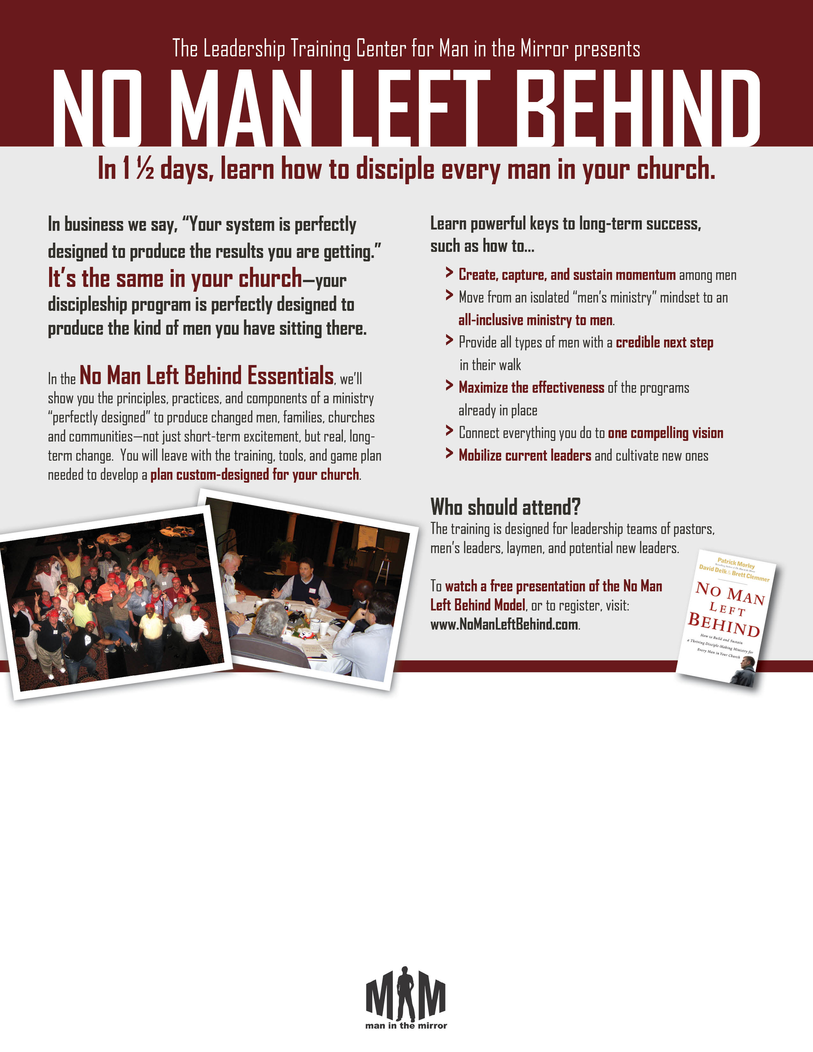
May 6-7 in Naples, FL
Friday: 6:30 p.m. to 9:30 p.m. ~ Saturday: 7:30 a.m. to 4:00 p.m.
Hosted at Covenant Church of Naples PCA ~ Co-Sponsored by the SW Florida Coalition for Men’s Discipleship

Tuition Details
Register by April 22nd for the early bird rate of $149.
Regular tuition is $169 and includes Saturday meals, the training workbook, textbook, and all materials.
Full time clergy: $139.
Limited Special Offer
Register five or more by April 22nd and receive a free NMLB Courseware Facilitator Set!
Call Bryan Richardson to reserve your team’s
NMLB Courseware: 407-472-2119.

Trainer Brett Clemmer
Brett Clemmer is Vice President of Man in the Mirror and Co-Author of the book No Man Left Behind. He helped establish the Leadership Training Center and speaks regularly at retreats, churches, workshops and conferences internationally and across the U.S.

His passion is to make the church relevant to younger men and men on the fringe. Brett and his wife Kimberly live in Casselberry, Florida, and have two children.

